Number of people in the house

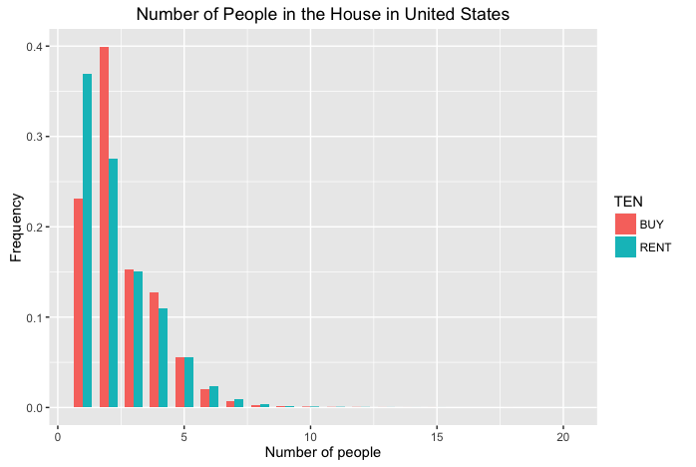

We can see there is a negative relationship between number of people in the house and the rent rate and two-people household has the highest buy rate. Reason behind this is obvious, people has more buying power and demand when number of people increases.

Rent vs House Price

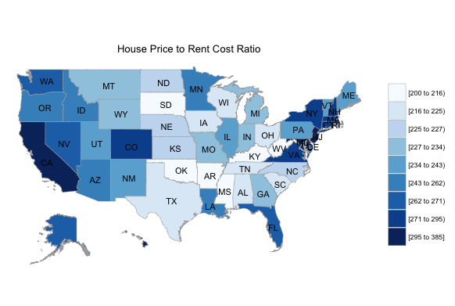

From the map we can see house along coast lines has the highest House Price to Rent Cost ratio, which means it is very expensive to buy a house near the coast lines compare to rent. In contrast, mid-western has the lowest ratio which means people tend to rent in these areas.

Industry

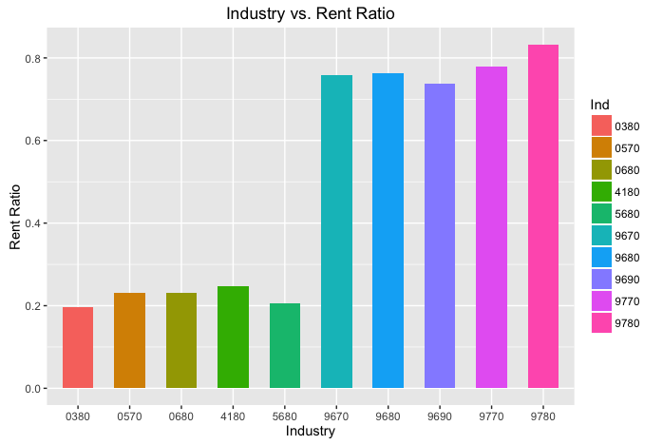

From the graph we can see people from US army, air force, navy or marines has the highest rent ratio. People work in coal mining, electricity generation, mineral and fuel which are energy-related industries have the lowest rent rate.

Age

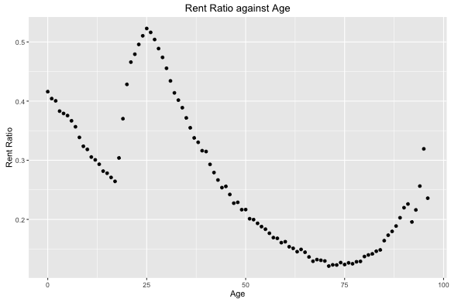

From the graph we can see there is a very clear decreasing line for rent ratio from age 25 to age 75, that’s because people have more buying power when get older. There are fluctuations below age 25 and beyond age 75, this may due to the family influence.

Marriage

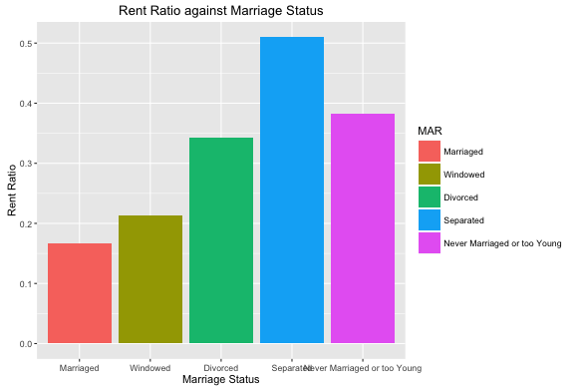

From the picture we can find separate status has the highest rent ratio and marriaged status has the lowest rent ratio.

Education

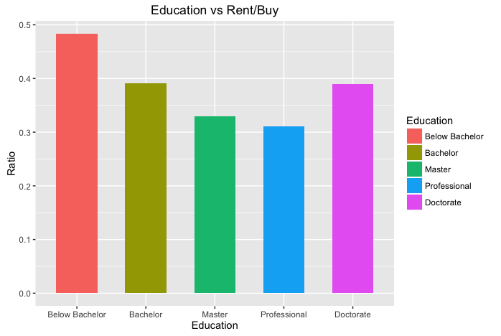

From the graph we can see rent ratio decrease as people get higher education, which due to the higher salary. However, we found doctor degree has the second highest rent ratio. Maybe doctors prefer doing research rather than work.